**CREATE**

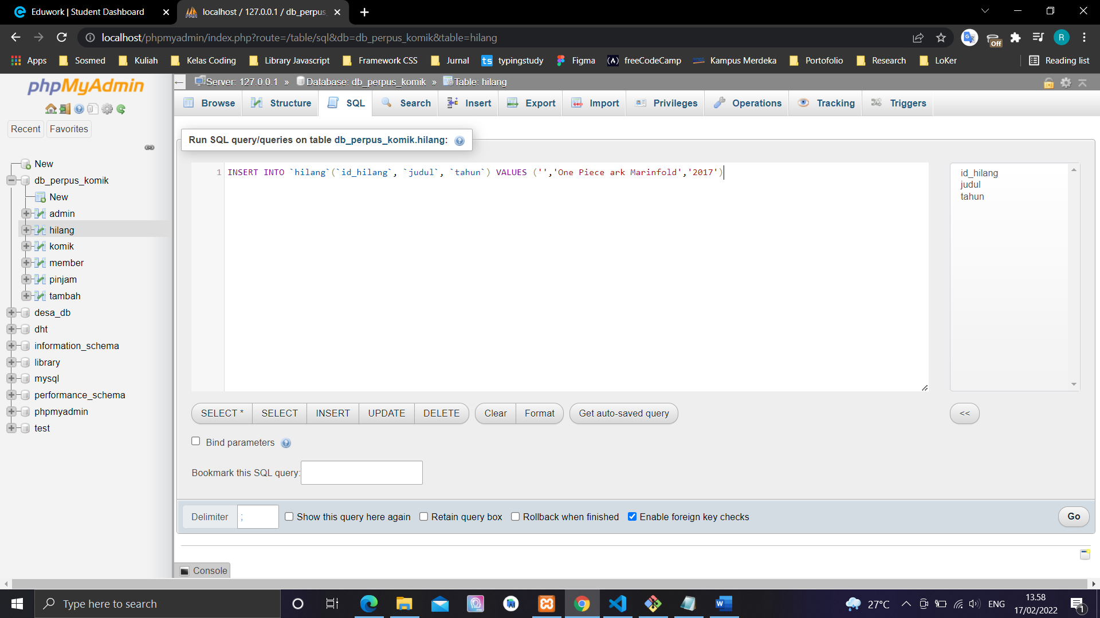

INSERT INTO `hilang`(`id_hilang`, `judul`, `tahun`) VALUES ('','One Piece ark Marinfold','2017')

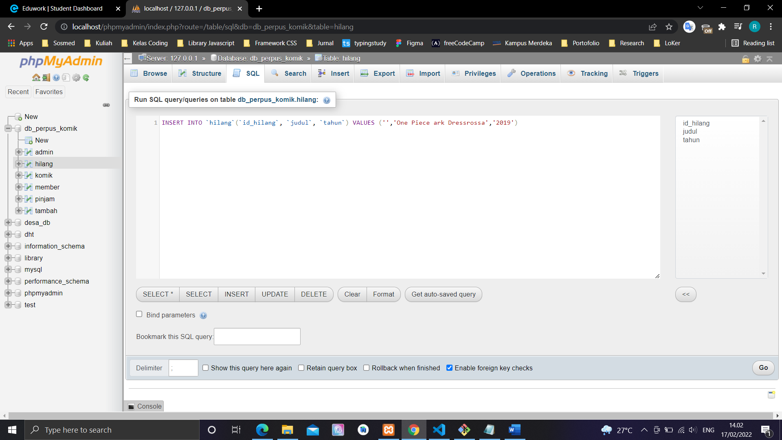

INSERT INTO `hilang`(`id_hilang`, `judul`, `tahun`) VALUES ('','One Piece ark Dressrossa','2019')

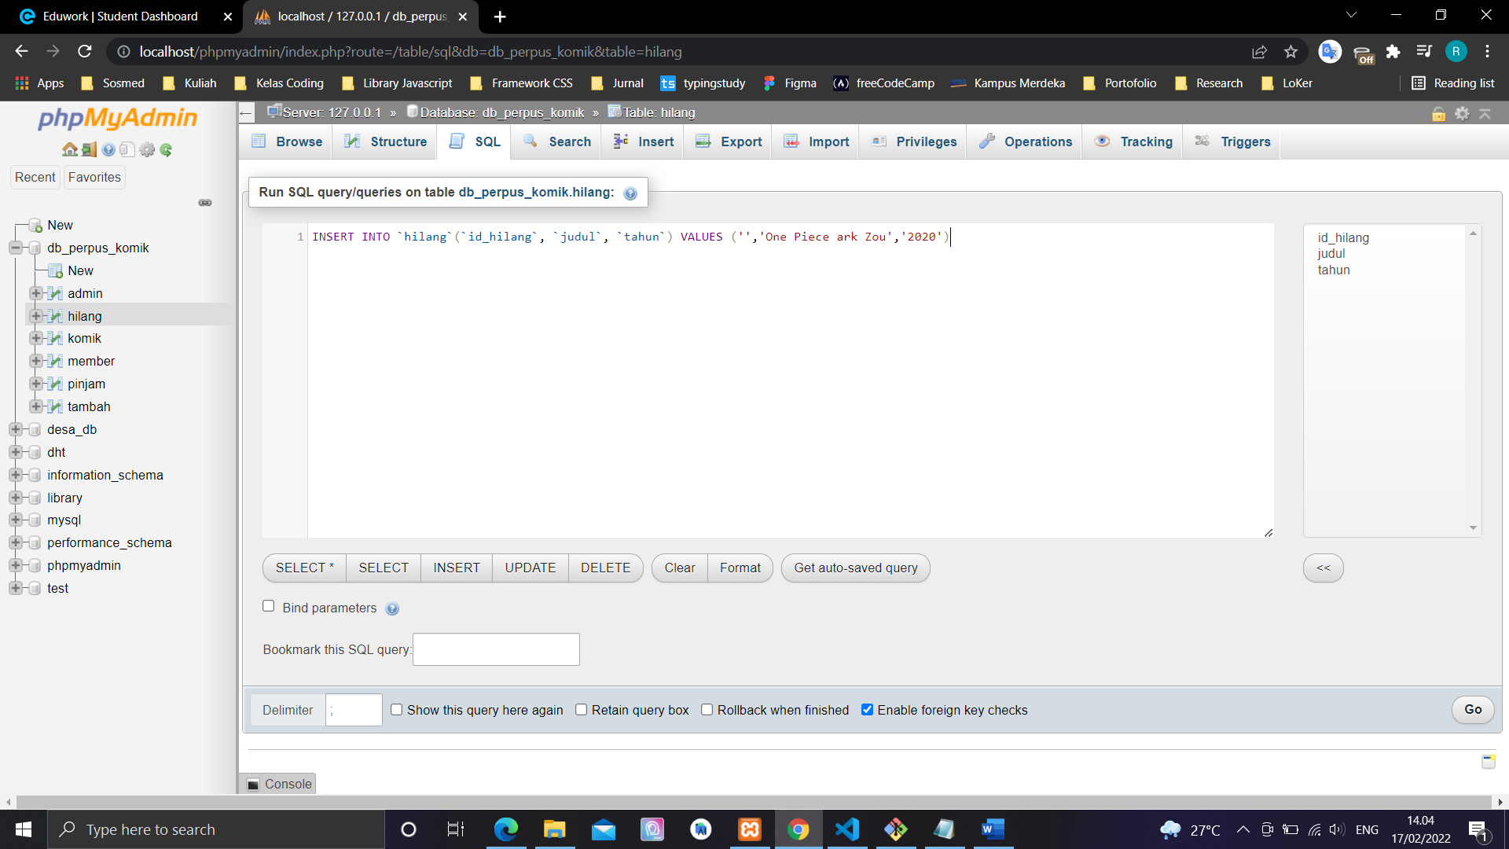

INSERT INTO `hilang`(`id_hilang`, `judul`, `tahun`) VALUES ('','One Piece ark Zou','2020')

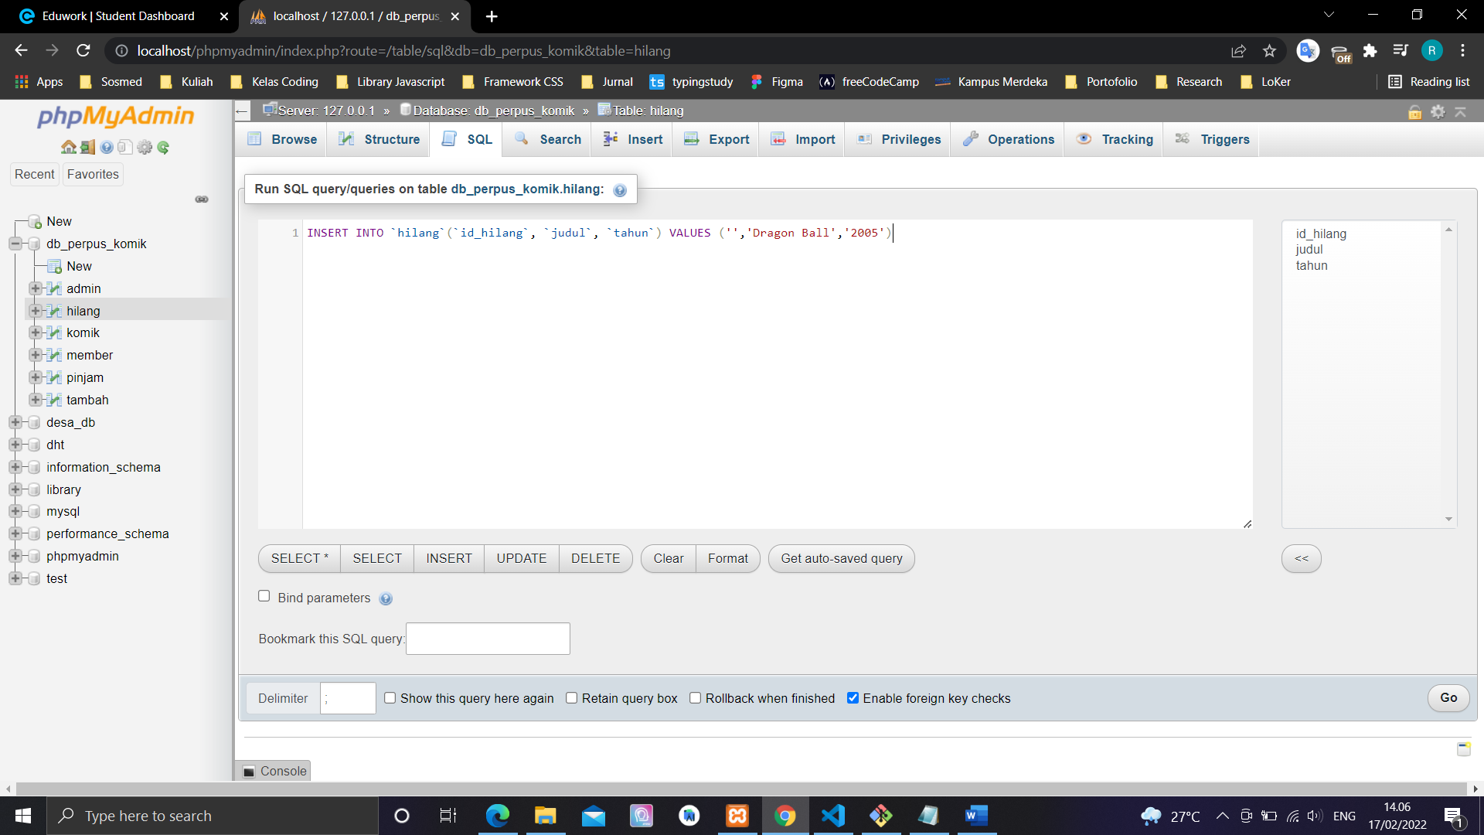

INSERT INTO `hilang`(`id_hilang`, `judul`, `tahun`) VALUES ('','Dragon Ball','2005')

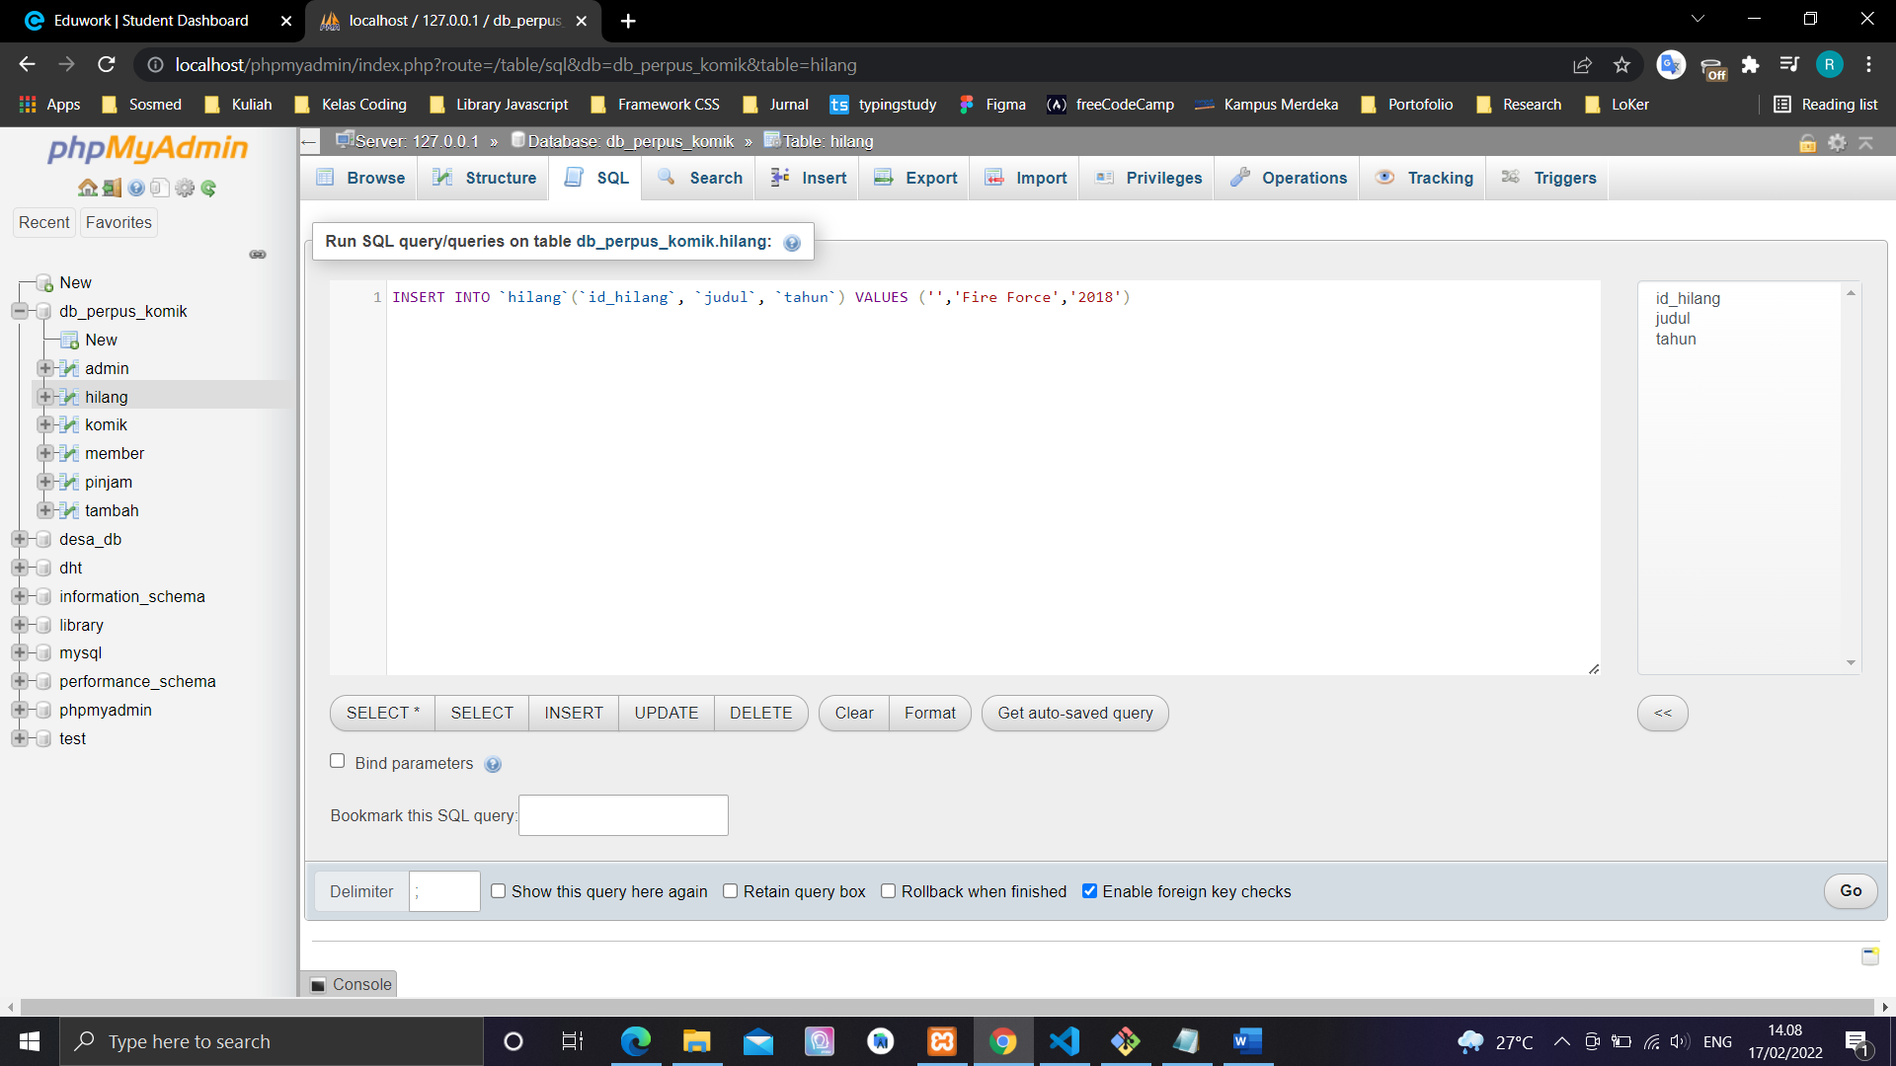

INSERT INTO `hilang`(`id_hilang`, `judul`, `tahun`) VALUES ('','Fire Force','2018')

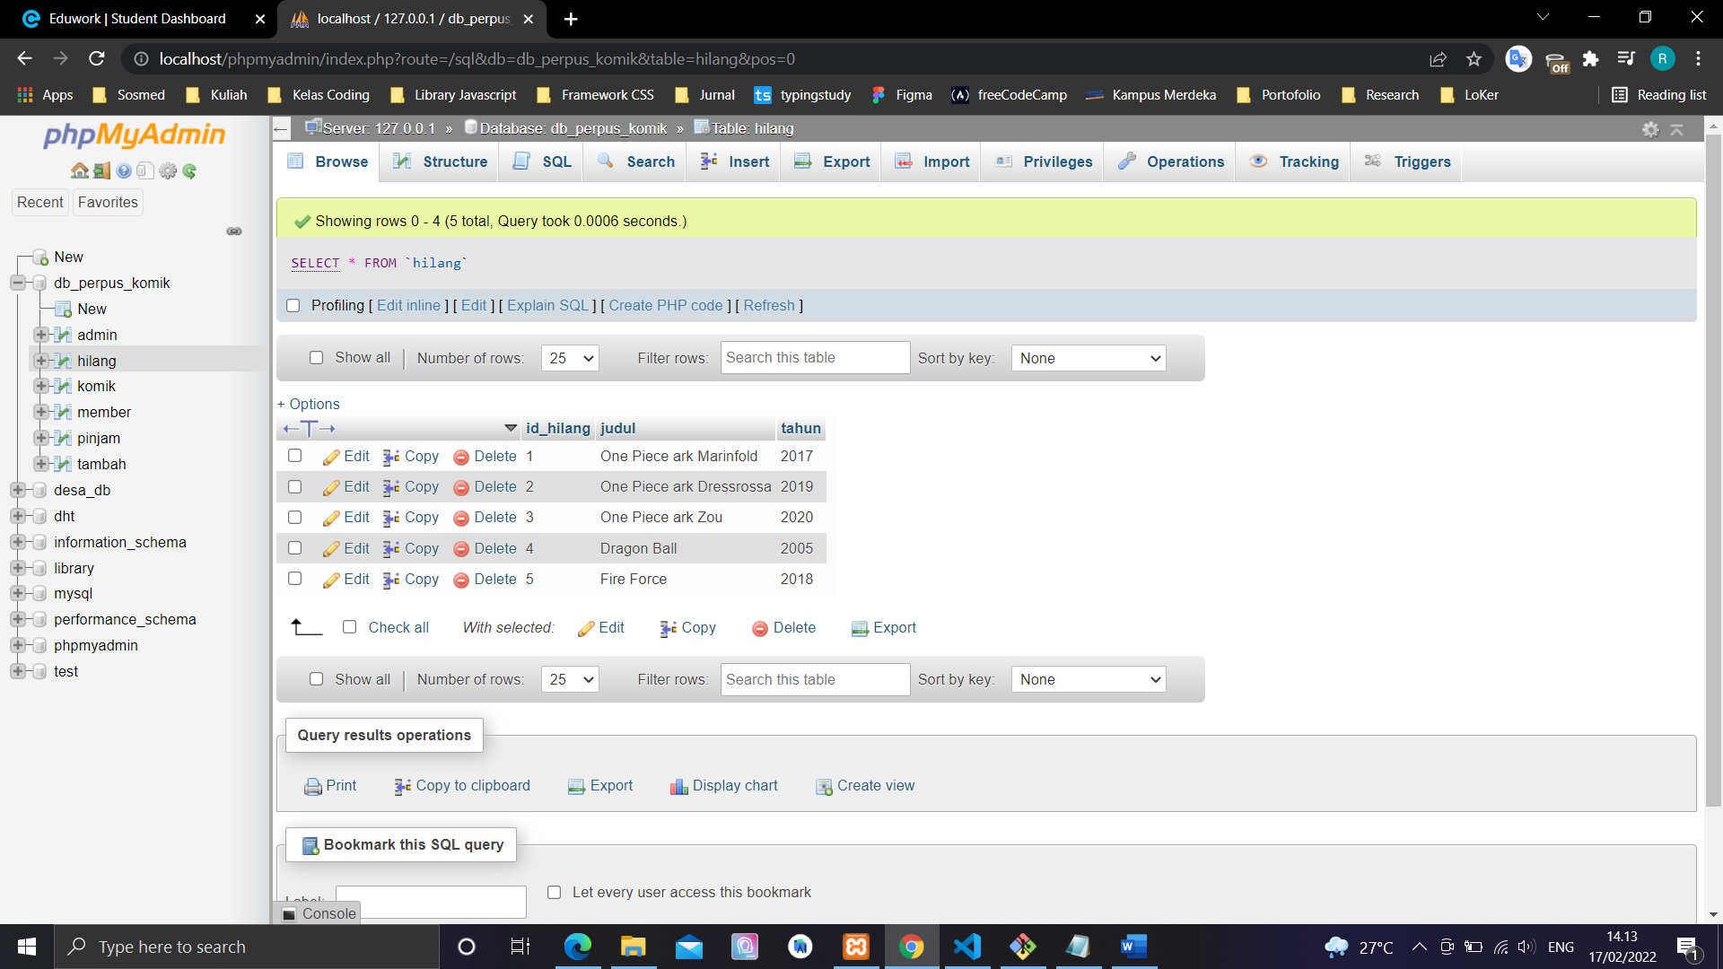

**UPDATE**

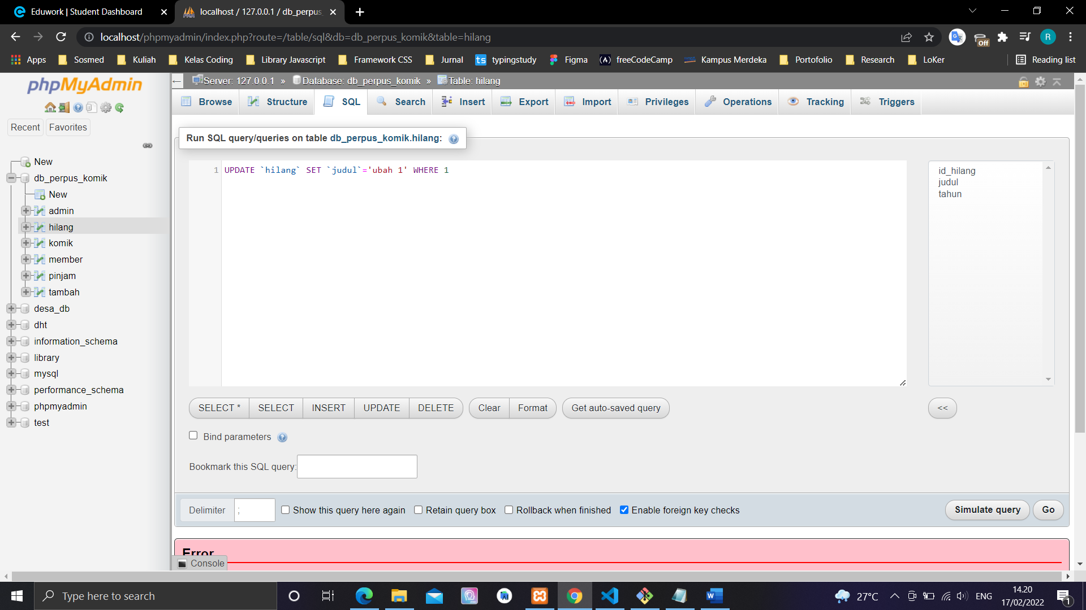

UPDATE `hilang` SET `judul`='ubah 1' WHERE 1

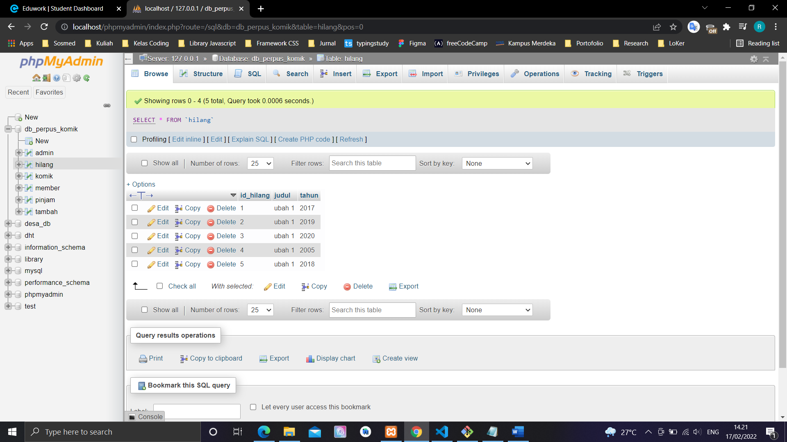

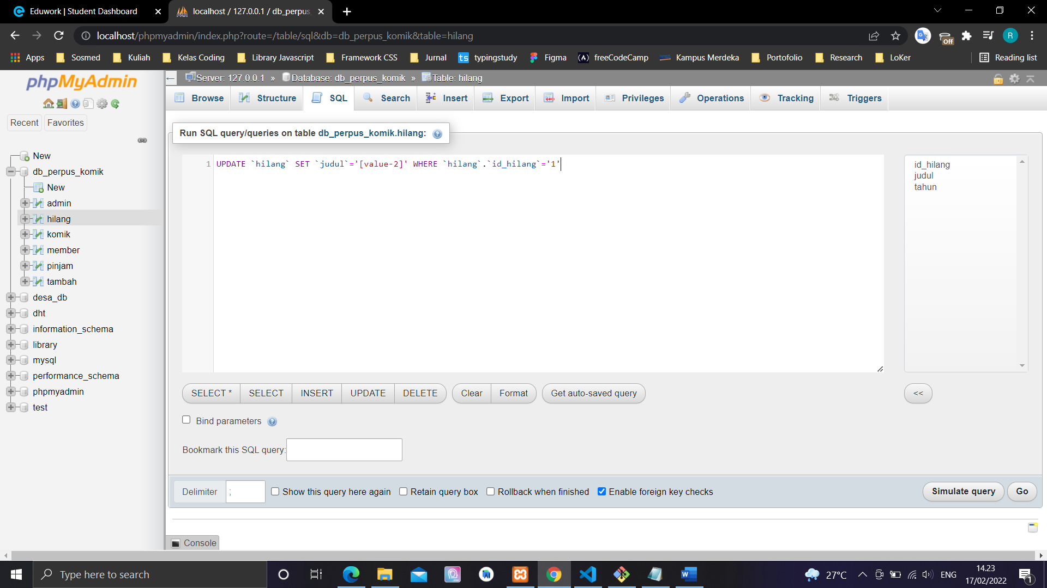

UPDATE `hilang` SET `judul`='[value-2]' WHERE `hilang`.`id_hilang`='1'

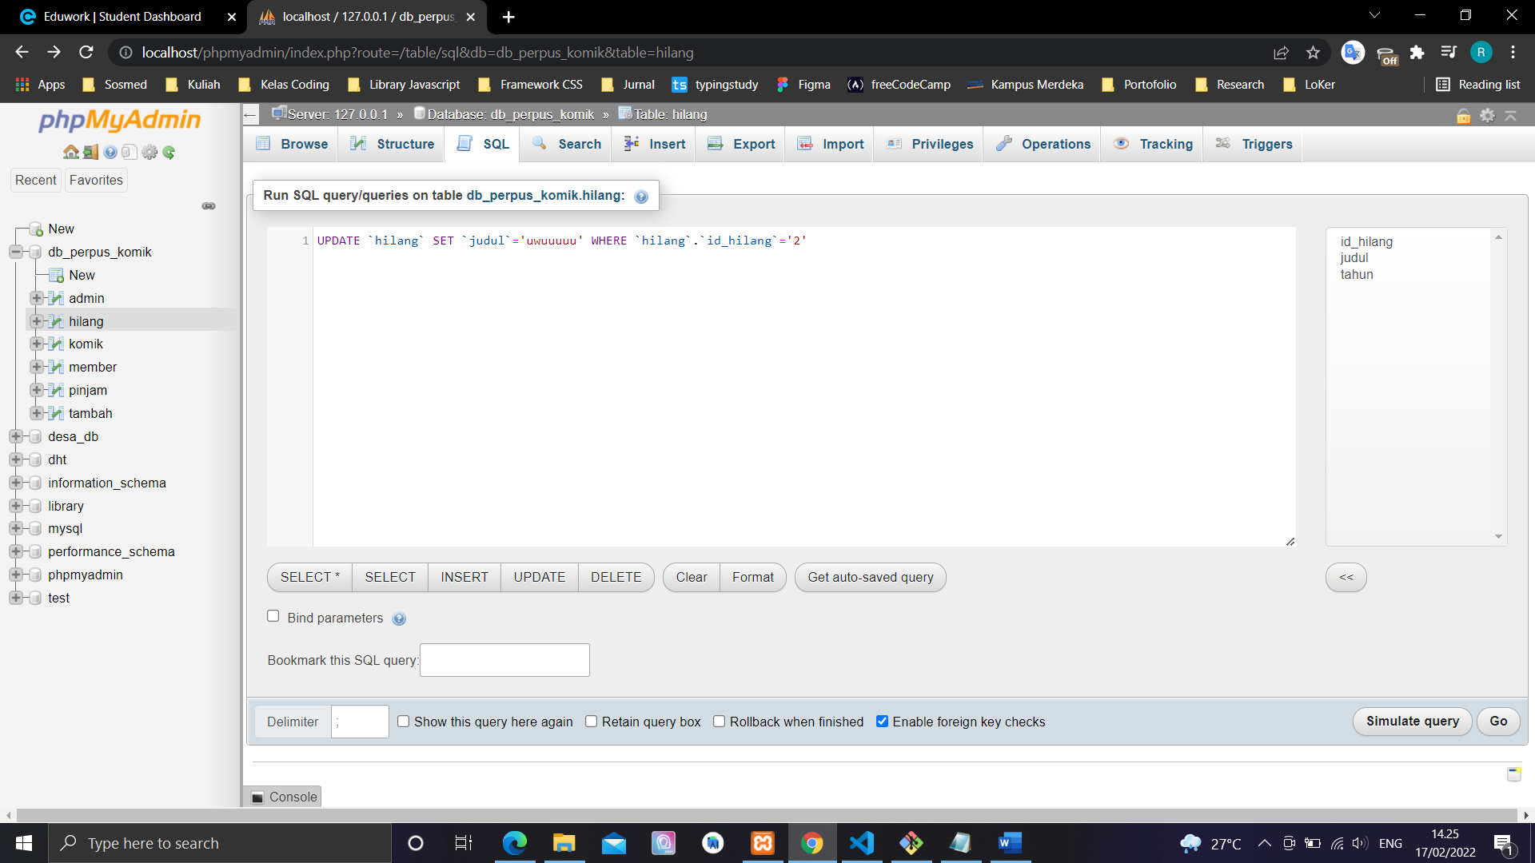

UPDATE `hilang` SET `judul`='uwuuuuu' WHERE `hilang`.`id_hilang`='2'

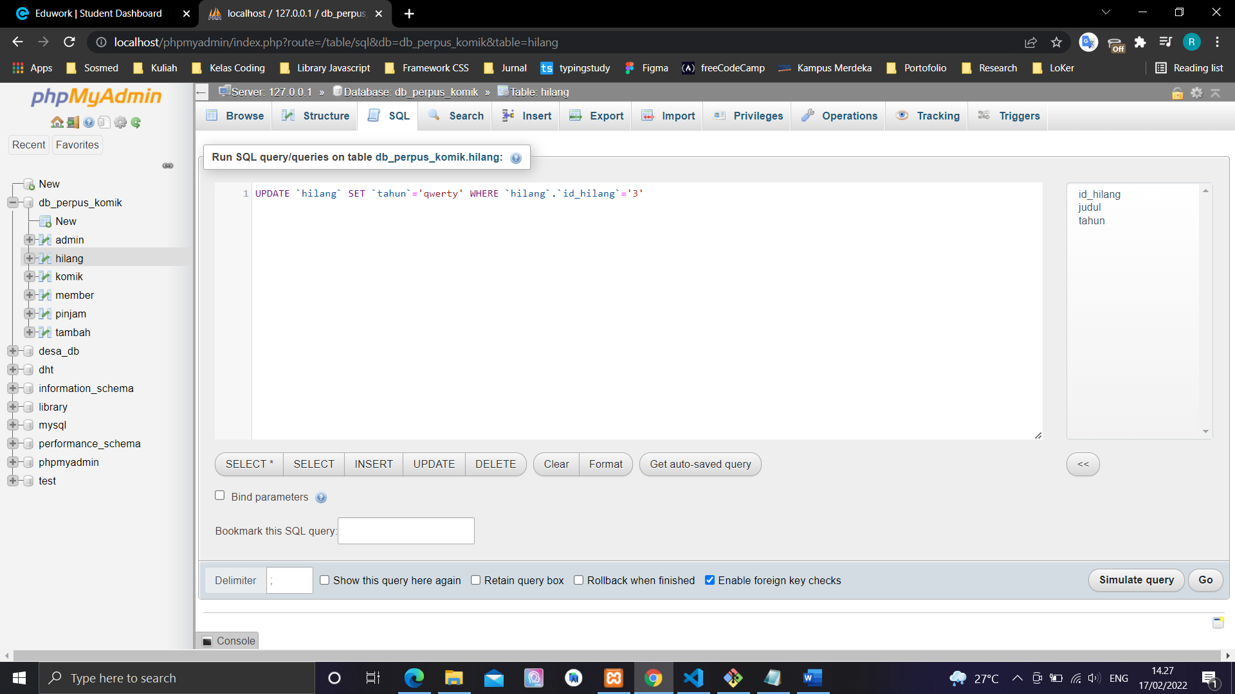

UPDATE `hilang` SET `tahun`='qwerty' WHERE `hilang`.`id_hilang`='3'

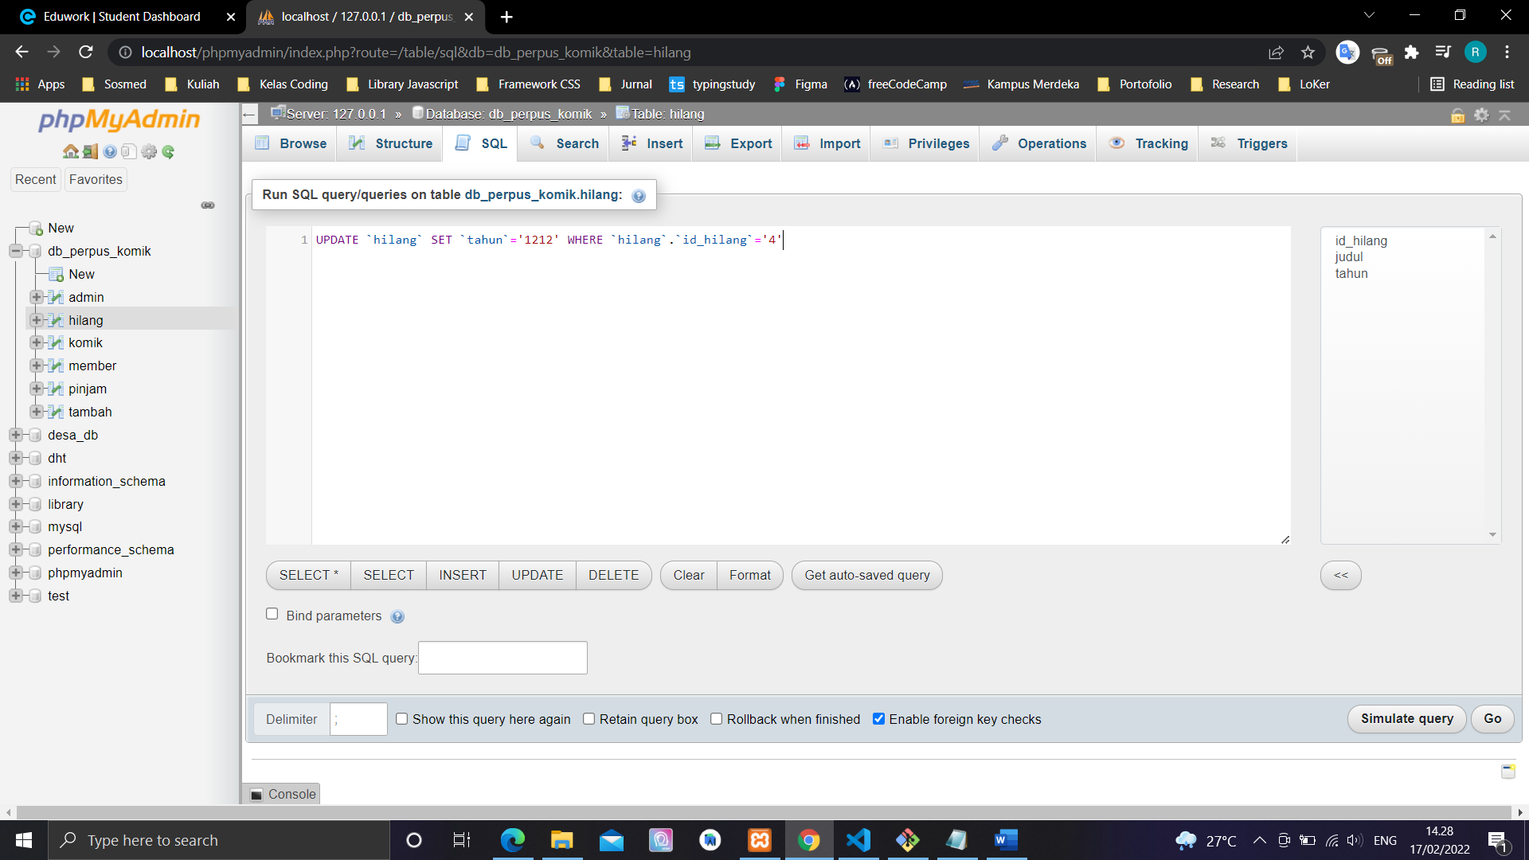

UPDATE `hilang` SET `tahun`='1212' WHERE `hilang`.`id_hilang`='4'

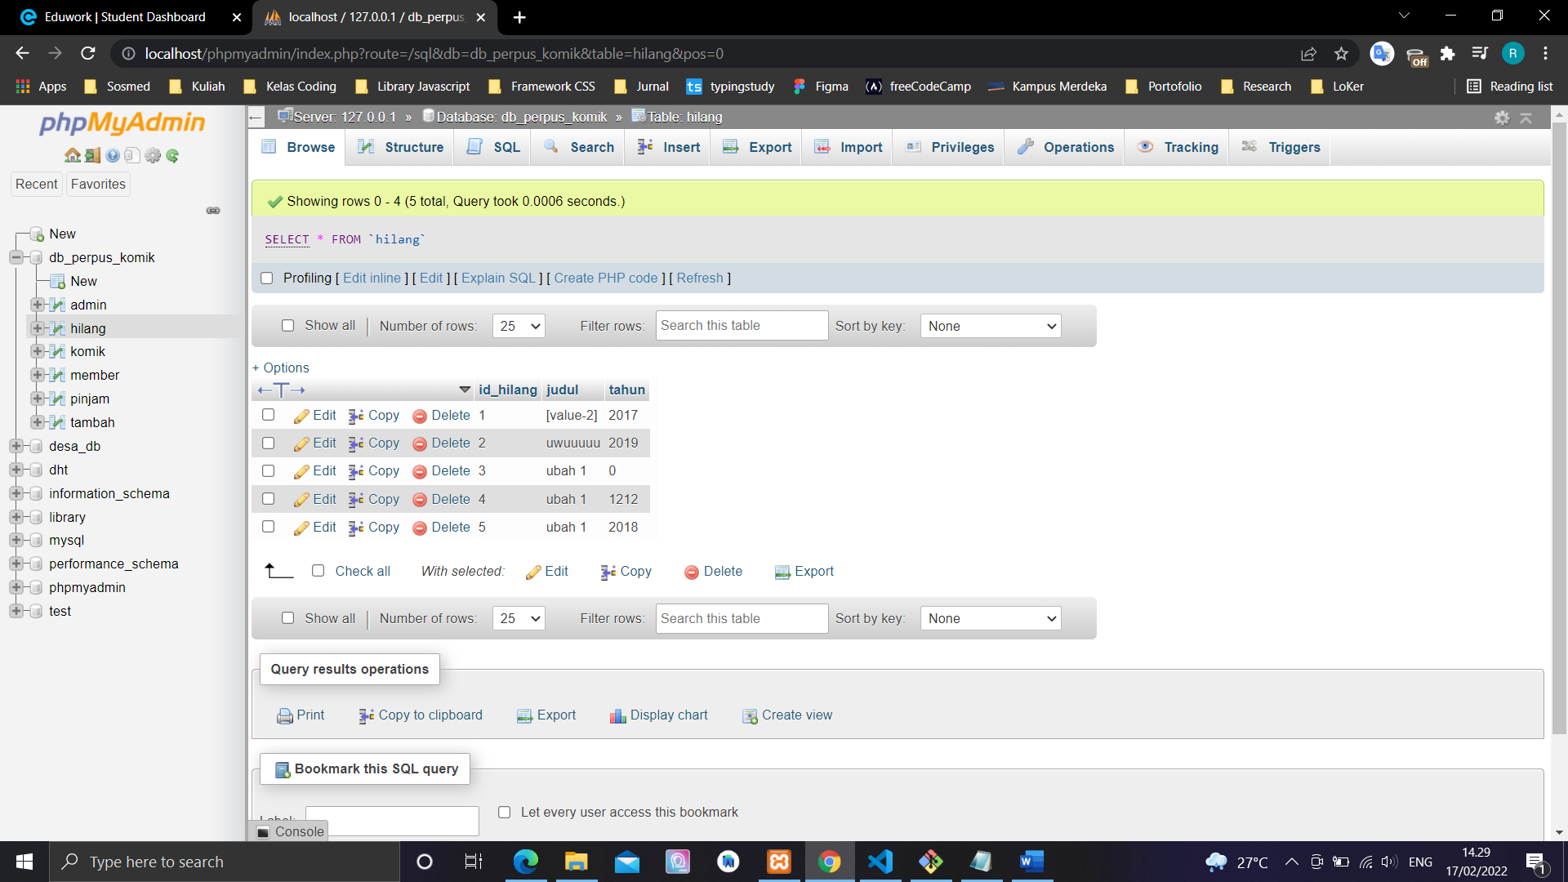

**DELETE**

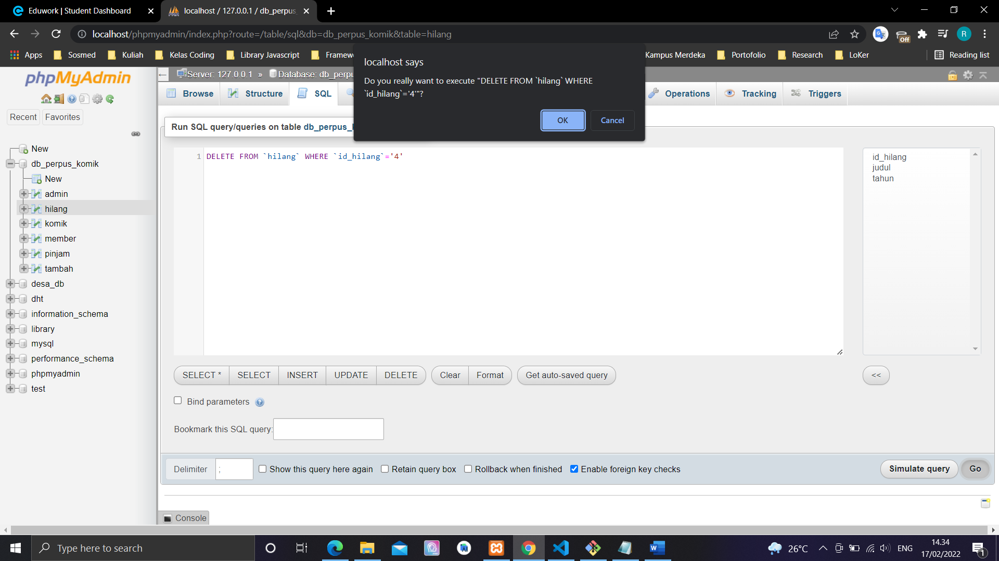

DELETE FROM `hilang` WHERE `id_hilang`='4'

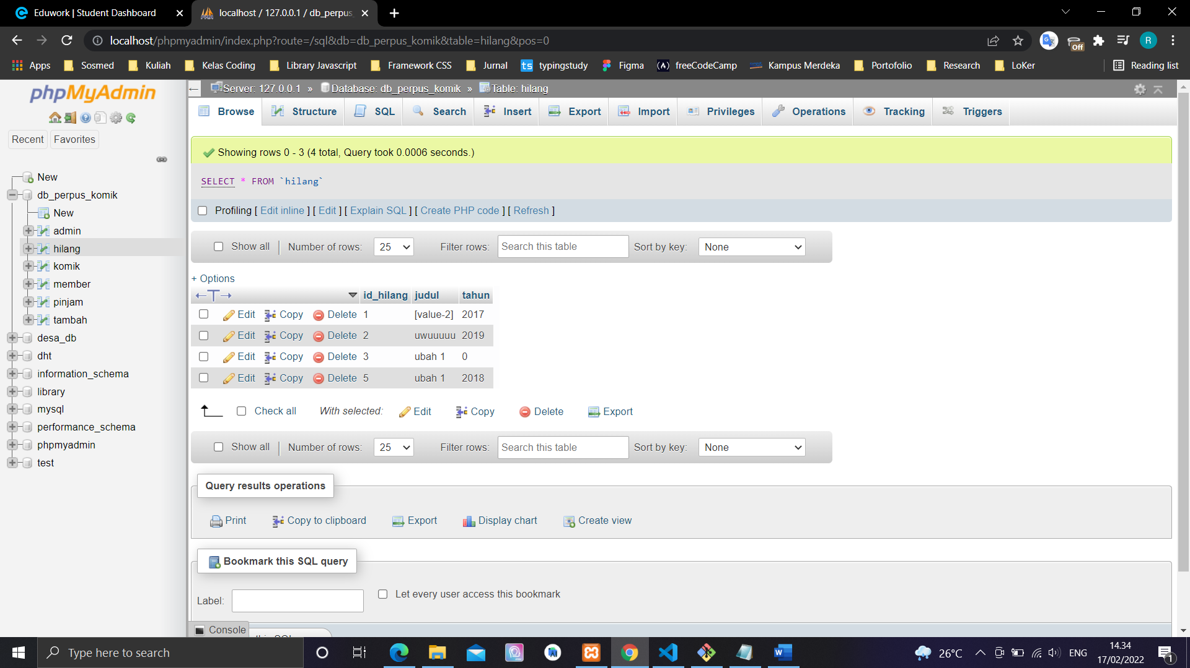

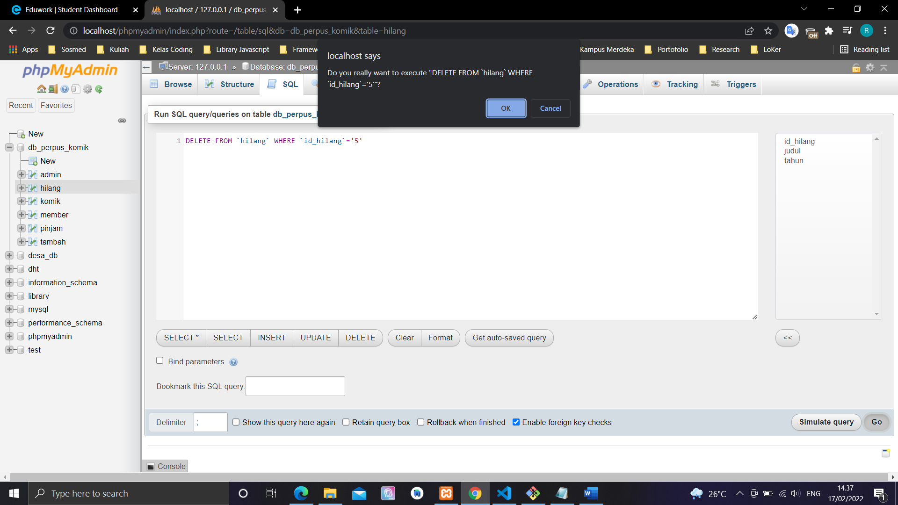

DELETE FROM `hilang` WHERE `id_hilang`='5'

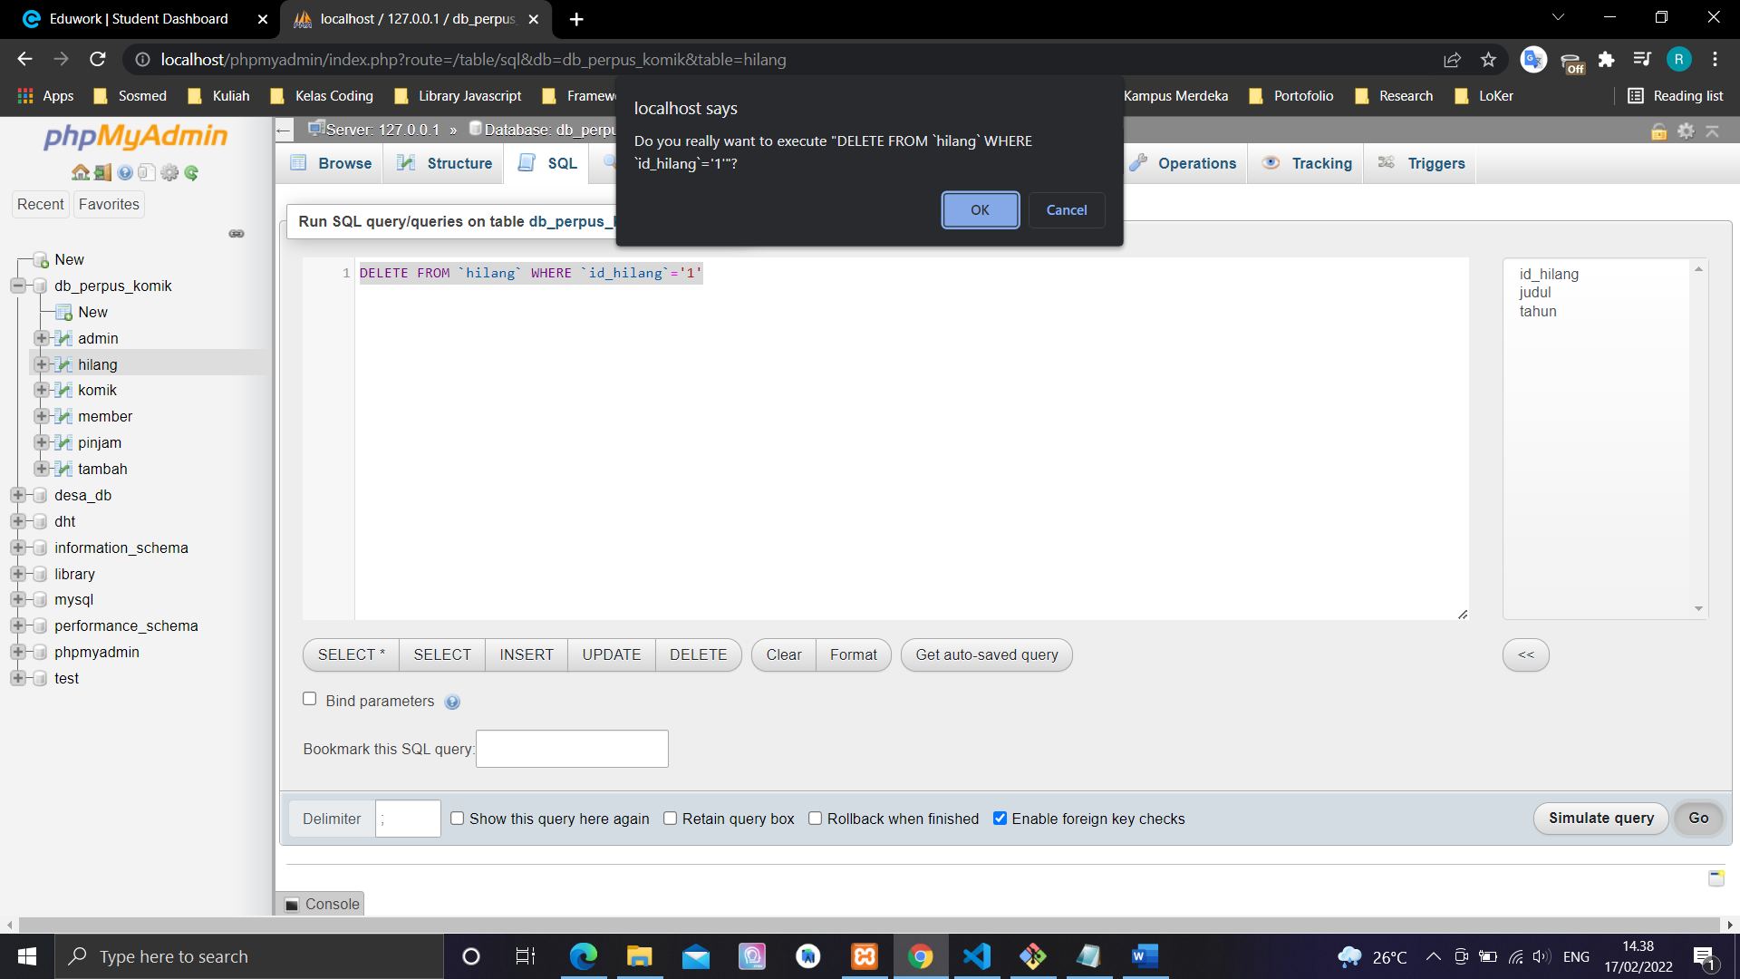

**DELETE FROM `hilang` WHERE `id_hilang`='1'**

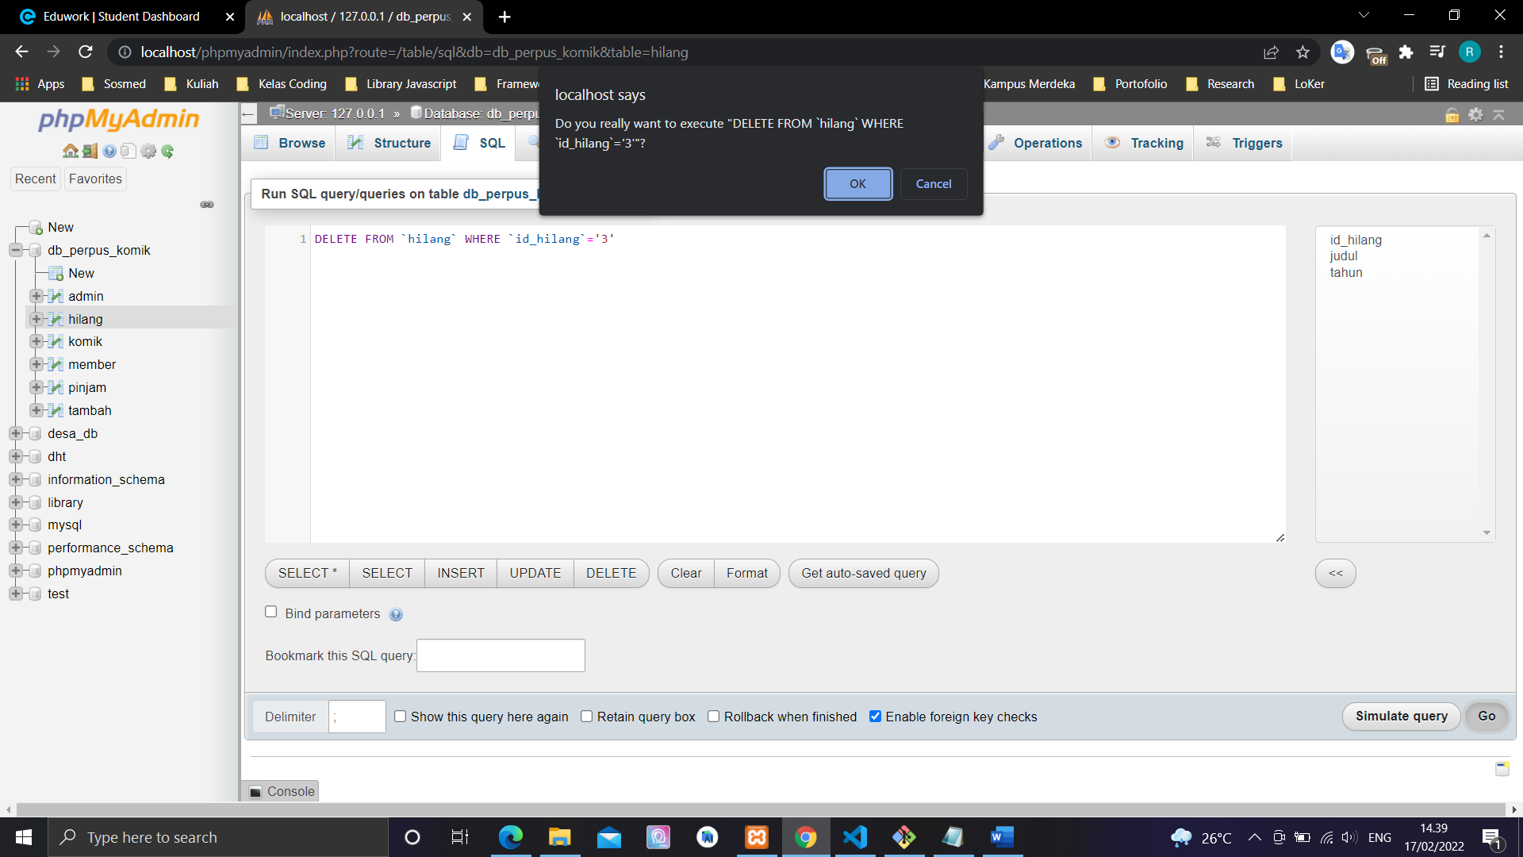

**DELETE FROM `hilang` WHERE `id_hilang`='3'**

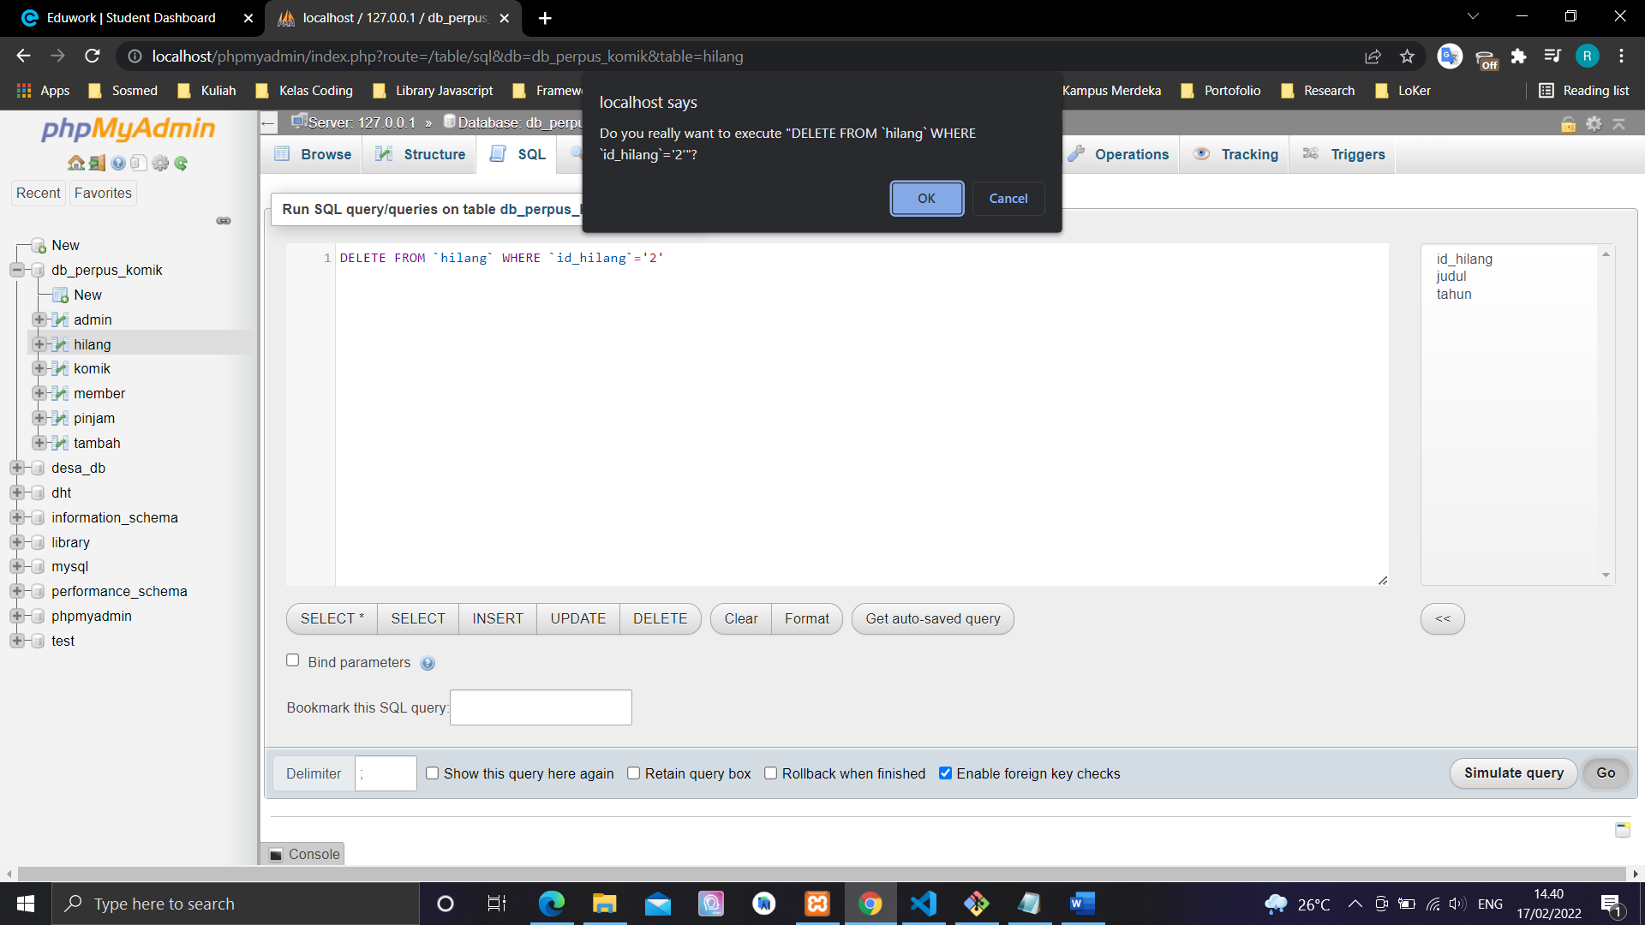

**DELETE FROM `hilang` WHERE `id_hilang`='2'**

